Phase 2 :org setup and configuration

Step1-

Go to salesforce developer org id

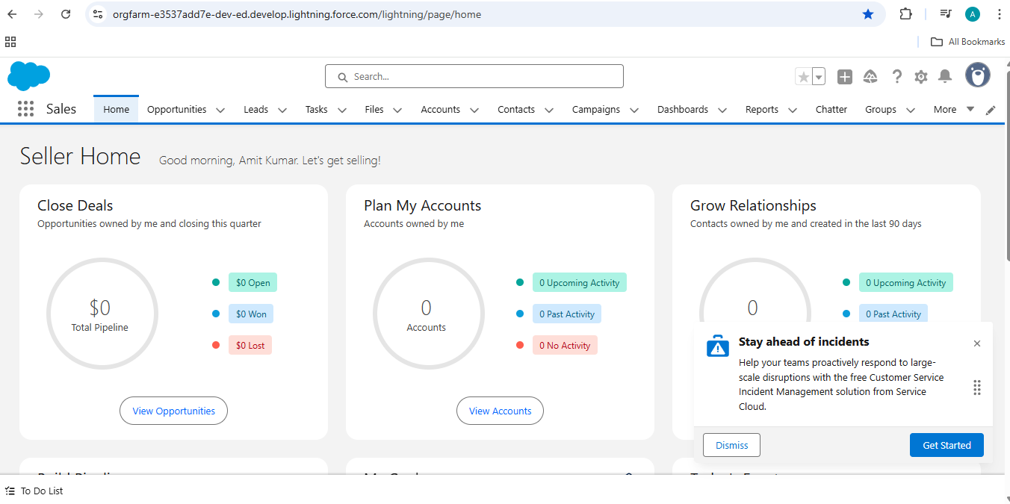

Click on the setup and search for company information(In one salesforce developer org we can have only one company)

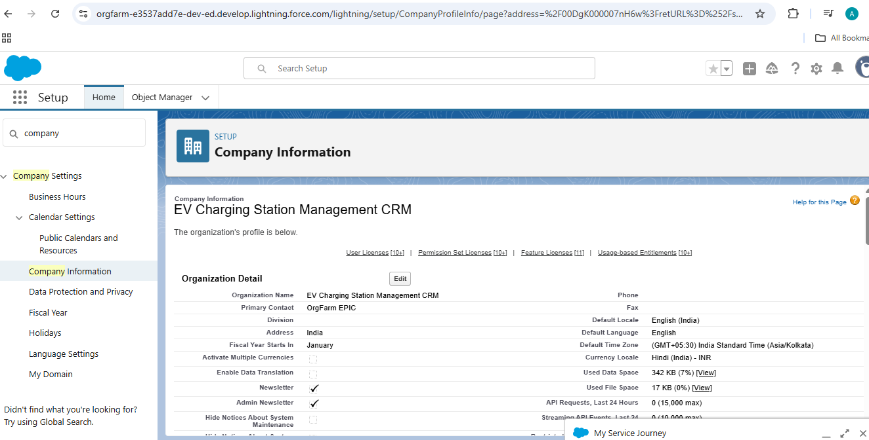

Step2

Fiscal year settings

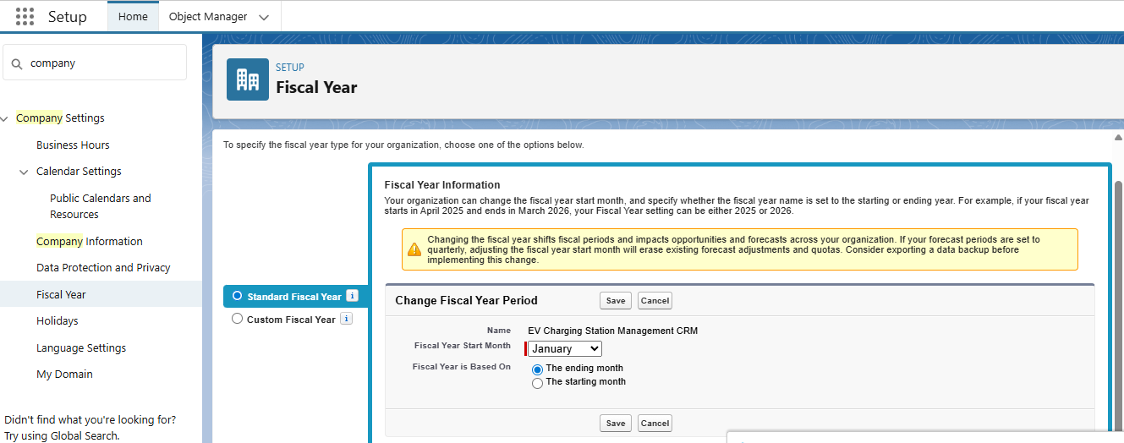

Step3

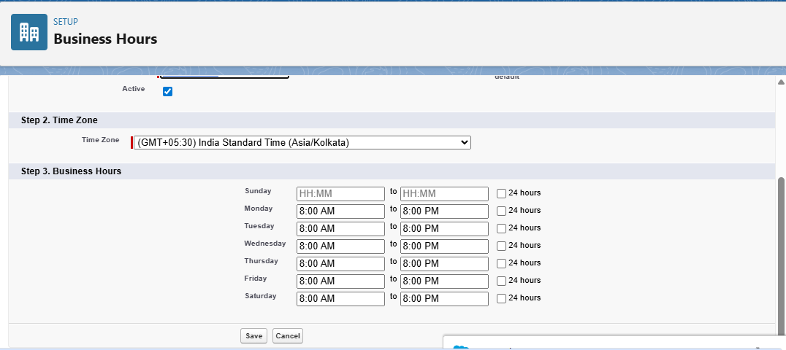bussiness hours setup.

Step4

Holidays setup

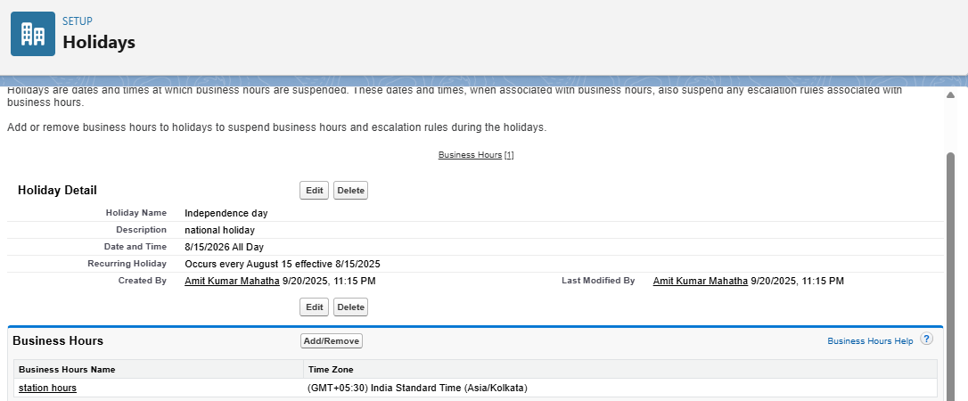

Linked with the business hours “Station Hours”

Step5:

Email setup , when ever any user will book charging point a confirmation mail will go through this mail

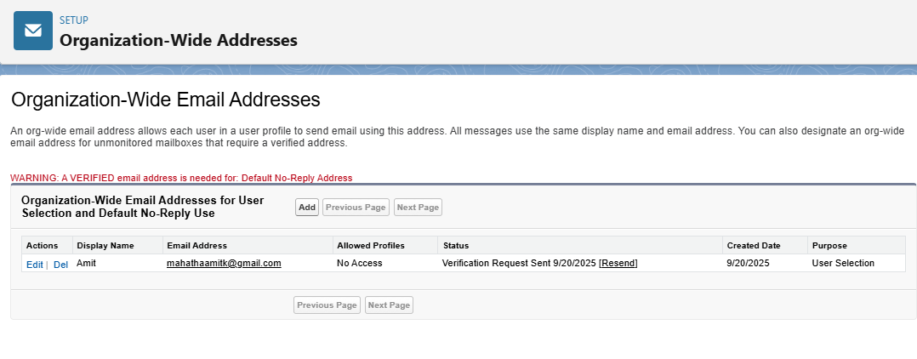

Step5:

Create roles (hierarchy)

Admin (top)

* Station Manager  
  + Customer Agent
  + Maintenance Staff

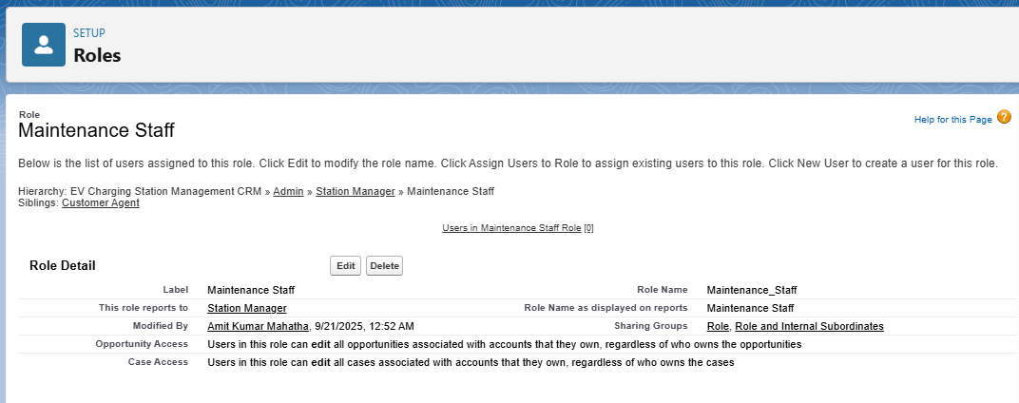

Step6

Profile setup

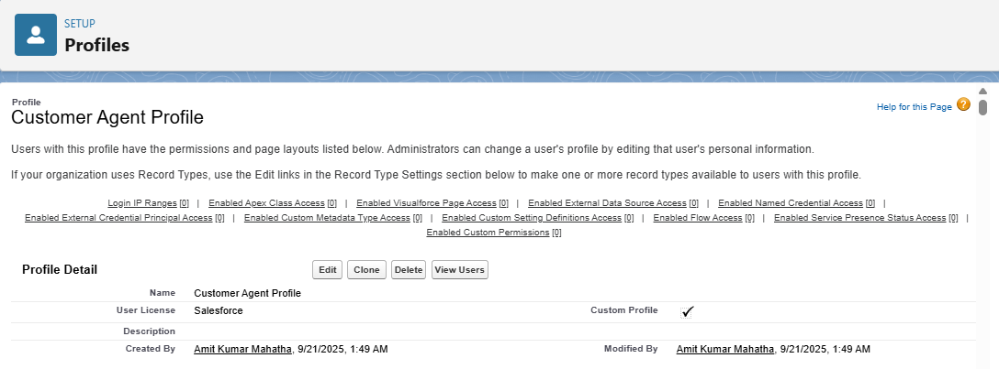

Step7

Permission setup

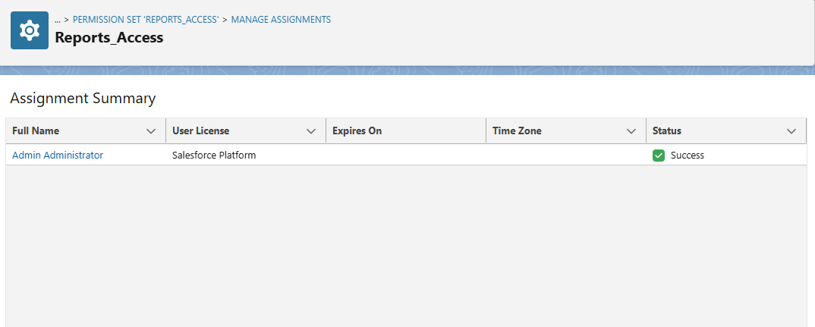

Step8:

Creating custom objects

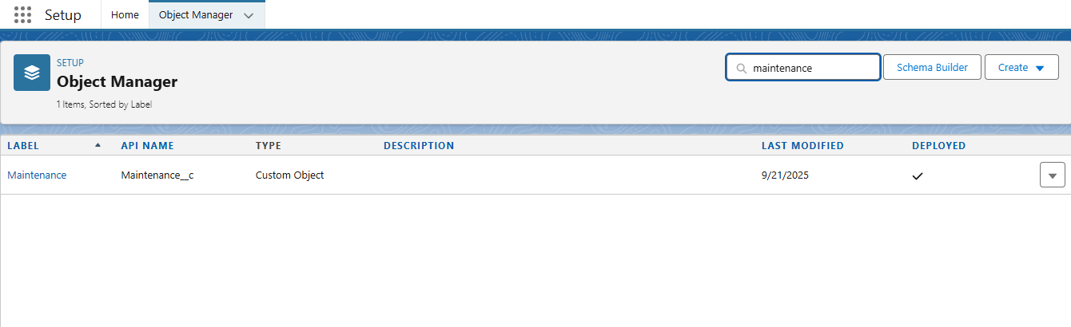

Step9:

Setting up custom object setting for profiles

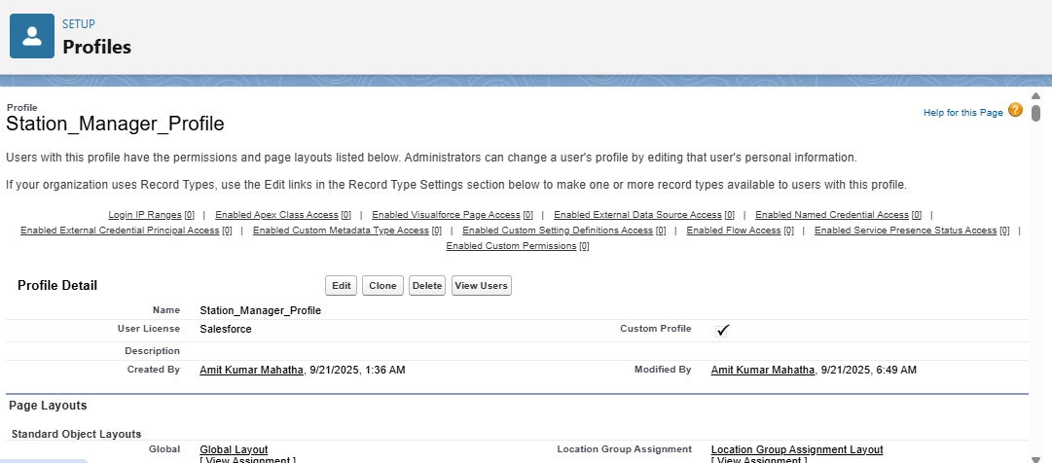

Step10:

Sharing settings

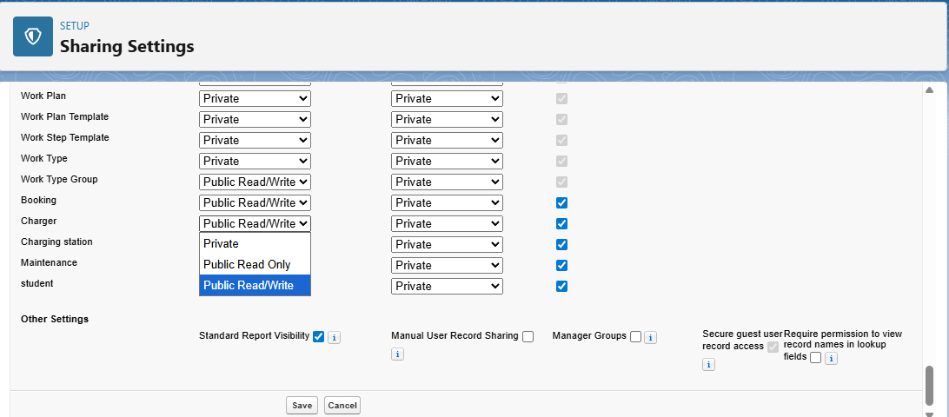

Step 11:

Create sharing rules for manager

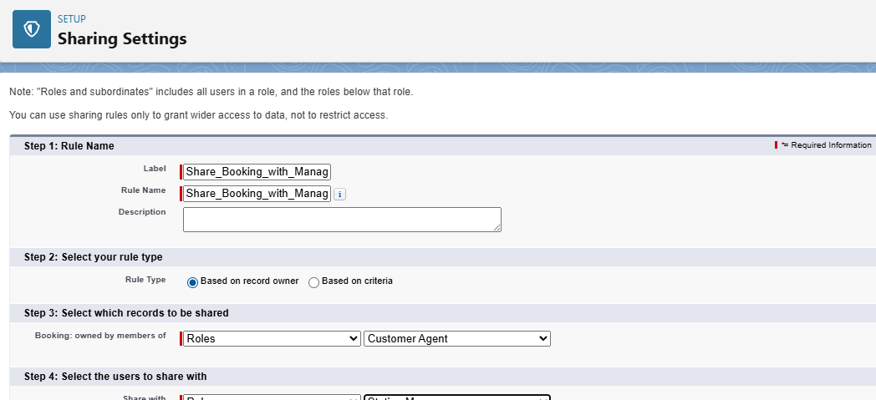

Step12:

Login hours setup

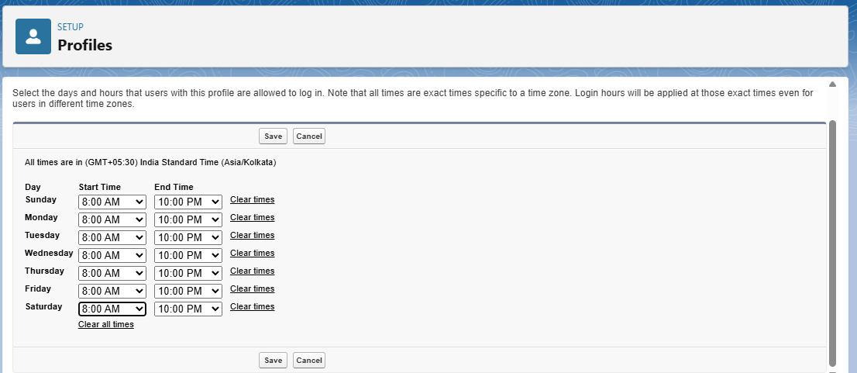

Step13:

IP ranges setup(nahi kiye hai)

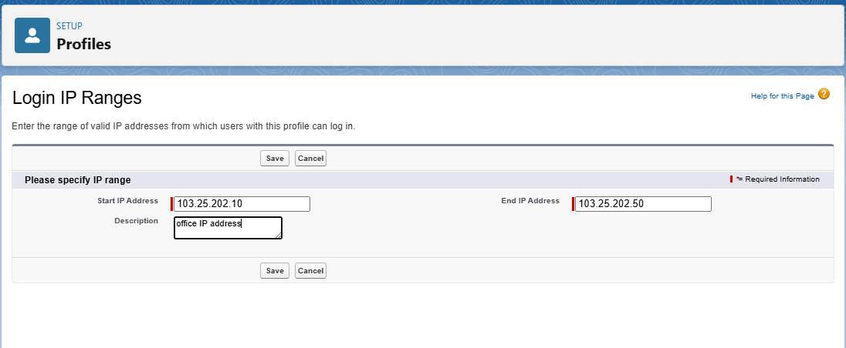

Step14:

Lightning setup

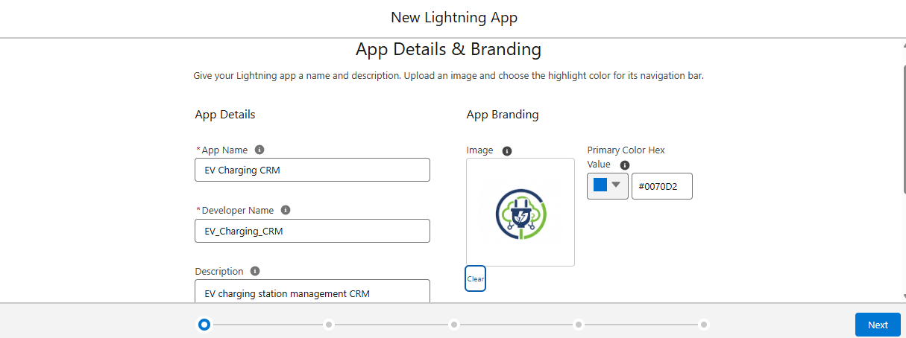

Utility settings(appears at bottom)

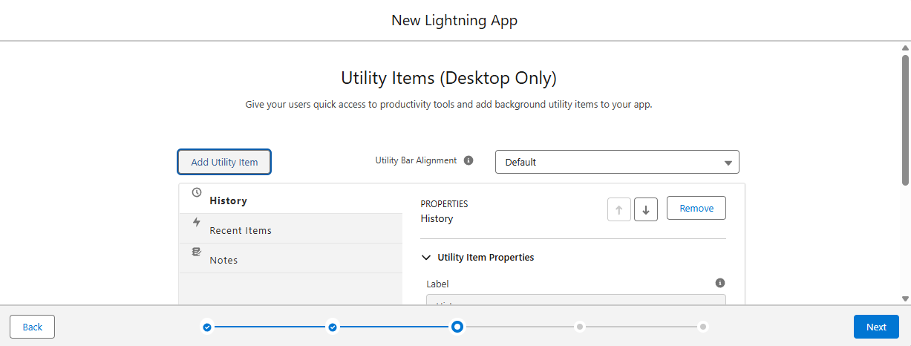

Creating the custom objects tabs

